Oracle Database Administration Services

Case Study: Database Locks



This document contains proprietary information of Wipro Infotech – MIT. No part of this publication may be reproduced, stored in a retrieval system or transmitted in any form or by any means, whether electronic, mechanical, photocopying, recording or otherwise, without the prior written permission of Wipro Infotech – MIT. The information contained herein is confidential to Wipro Infotech – MIT and <Customer Name> and shall not be distributed to any persons other than those involved in the assessment and delivery of services. Wipro Infotech – MIT reserves the right to revise and update this document as and when required. Wipro Infotech – MIT reserves the right to withdraw the document excluding customer specific information at the time of termination of services.

All product names referenced herein are trademarks of their respective companies.
Document Management Information
Document Title : Case Study: Database Locks
Document Status : Draft / Review / Approval / Final
Document Publication History
(All revisions made to this document must be listed in chronological order)
Version | Date | Author(s) | Remarks
1.0 | 01-11-2008 | Buvanesh Mohana Murugan | Initial Draft Document
 | 24-07-2014 | Vineet Walia | Review and update
 | 13-07-2016 | Hemanti Thackeray | Review and update
Document Review and Approval History
(All revisions must be approved. Review and Approval can be done by an internal source or by the customer)
Version | Date | Reviewer & Approver | Remarks | Signature
1.0 | 20-11-08 | Premchand Ryali | Review
1.0 | 13-07-2016 | Jagdish Chauhan | Approval
Document Distribution List
S.No | Name and Company | Purpose
1
2

TABLE OF CONTENTS
1. Purpose 1
2. Database Locks 1
2.1 Steps To Remove Locks. 1
2.1.1. Using V$Lock 1
2.2 Queries To Determine Locking: 4
2.4 Killing The Process: 5
2.4.1 Using Alter System: 5
2.5 Check After Killing The Session 6
3. Note: 7
3.1 Killing Process Is Not A Best Practice. 7
3.2 Killing Session Using Oem: We Can Kill Sessions Using Oem’salso.7
4. References And Links 9

Purpose
This document is prepared for the management and troubleshooting of Oracle Database Administration Services at <Customer Name>.

Database Locks
Locks are mechanisms that prevent destructive interaction between transactions accessing the same resource.

General Object Type Affected By Locks:
User objects, such as tables and rows (structures and data) System objects not visible to users, such as shared data structures in the memory and data dictionary rows

Steps to remove locks.
There are 2 ways to remove locks:
- Using v$lock.
- Using OEM.

2.1.1. Using v$lock
v$lock:

The information here contains the view description from the Oracle9i documentation along with any additional related to this view. Earlier versions of Oracle may not include all columns.

Oracle9i Information

This view lists the locks currently held by the Oracle server and outstanding requests for a lock or latch.

Column | Datatype | Description
ADDR | RAW(4) | Address of lock state object
KADDR | RAW(4) | Address of lock
SID | NUMBER | Identifier for session holding or acquiring the lock
TYPE | VARCHAR2(2) | Type of user or system lock  The locks on the user types are obtained by user applications. Any process that is blocking others is likely to be holding one of these locks. The user type locks are:  TM - DML enqueue  TX - Transaction enqueue  UL - User supplied  The locks on the system types are held for extremely short periods of time.
ID1 | NUMBER | Lock identifier #1 (depends on type)
ID2 | NUMBER | Lock identifier #2 (depends on type)
LMODE | NUMBER | Lock mode in which the session holds the lock:  0 - none  1 - null (NULL)  2 - row-S (SS)  3 - row-X (SX)  4 - share (S)  5 - S/Row-X (SSX)  6 - exclusive (X)
REQUEST | NUMBER | Lock mode in which the process requests the lock:  0 - none  1 - null (NULL)  2 - row-S (SS)  3 - row-X (SX)  4 - share (S)  5 - S/Row-X (SSX)  6 - exclusive (X)
CTIME | NUMBER | Time since current mode was granted
BLOCK | NUMBER | The lock is blocking another lock

Table 3-1 Values for the TYPE Column: System Types
System Type | Description | System Type | Description
BL | Buffer hash table instance | NA..NZ | Library cache pin instance (A..Z = namespace)
CF | Control file schema global enqueue | PF | Password File
CI | Cross-instance function invocation instance | PI, PS | Parallel operation
CU | Cursor bind | PR | Process startup
DF | Data file instance | QA..QZ | Row cache instance (A..Z = cache)
DL | Direct loader parallel index create | RT | Redo thread global enqueue
DM | Mount/startup db primary/secondary instance | SC | System commit number instance
DR | Distributed recovery process | SM | SMON
DX | Distributed transaction entry | SN | Sequence number instance
FS | File set | SQ | Sequence number enqueue
HW | Space management operations on a specific segment | SS | Sort segment
IN | Instance number | ST | Space transaction enqueue
IR | Instance recovery serialization global enqueue | SV | Sequence number value
IS | Instance state | TA | Generic enqueue
IV | Library cache invalidation instance | TS | Temporary segment enqueue (ID2=0)
JQ | Job queue | TS | New block allocation enqueue (ID2=1)
KK | Thread kick | TT | Temporary table enqueue
LA .. LP | Library cache lock instance lock (A..P = namespace) | UN | User name
MM | Mount definition global enqueue | US | Undo segment DDL
MR | Media recovery | WL | Being-written redo log instance

Queries to determine locking:
Blocking Queries (More than 5 Min):-
==================================
Script:

SQL> select SID, SQL_HASH_VALUE, count(*) from v$session where sid in (select sid from v$lock where BLOCK > 0 and ctime/60 > 5 and id1 > 900) group by SID, SQL_HASH_VALUE;

Output:

SID SQL_HASH_VALUE COUNT(*)
---------- -------------- ----------
321 2184291248 1
384 1741347688 1
784 0 1
845 366896086 1
958 2698940716 1
1628 2659984223 1
1632 3800980706 1
2043 476143364 1
2953 1736000101 1
4573 2184907408 1

10 rows selected.

Blocking Object (More than 5 Min):-
=================================

Script:

SQL> select object_name from user_objects where object_id in (select id1 from v$lock where BLOCK > 0 and ctime/60 > 5 and id1 > 900);

Output
OBJECT_NAME
-----------
GBL_REP_MONSHEET
VH_PSF
VH_FCAMP_INV
AM_DOCS
VH_RO
VH_RO

6 rows selected.

2.4 Killing the process:

2.4.1 Using alter system:

alter system kill session 'session-id,session-serial'

This command kills a session. The session-id and session-serial parameters are found in the v$session view (columns sid and serial#.

SELECT sid, serial#, username FROM V$SESSION;

SID SERIAL# USERNAME
---------- ---------- ------------------------------
321 85 SYS
384 1
784 8
845 23 OE
958 1
1628 1
1632 1
2043 1
2953 1
4573 1

alter system kill session '4573,1'

2.5 Check after killing the session
Execute the below query to check the lock is exiting.

Blocking Queries (More than 5 Min):-
==================================

SQL> select SID, SQL_HASH_VALUE, count(*) from v$session where sid in (select sid from v$lock where BLOCK > 0 and ctime/60 > 5 and id1 > 900) group by SID, SQL_HASH_VALUE;

SID SQL_HASH_VALUE COUNT(*)
---------- -------------- ----------
321 2184291248 1
384 1741347688 1
784 0 1
845 366896086 1
958 2698940716 1
1628 2659984223 1
1632 3800980706 1
2043 476143364 1
2953 1736000101 1

Note:

Killing process is not a best practice.
Killing session is not a best practice. To take the user's consent before killing the process. If a process is killed, the below error may come:
ORA-00600: internal error code, arguments: [17281], [1001], [0x7000002D1AD4270], [], [], [], [], []
ORA-01001: invalid cursor
Ignore these errors.

Killing session Using OEM: We can kill sessions using OEM’salso.

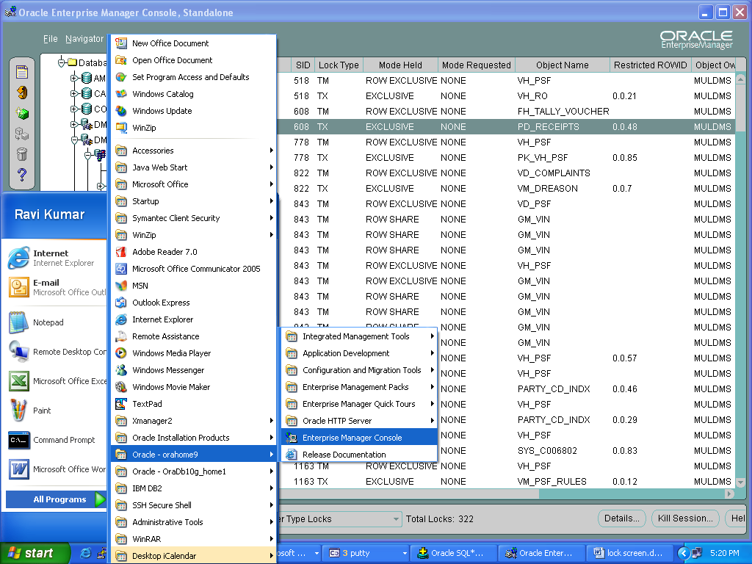

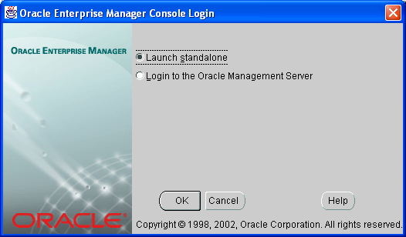
Click OK
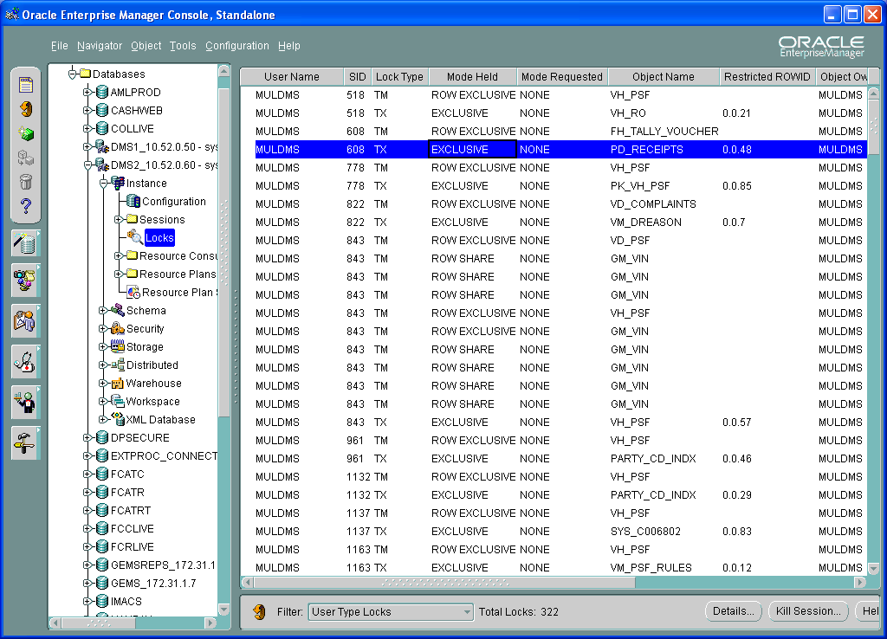

Select User Type Locks.

Click kill session…

Though we can kill sessions using OEM, its better practice to kill sessions using alter session command

References And Links
https://metalink.oracle.com/CSP/ui/index.html

